Autonomous Maze Solving Robot
Senior Capstone Design Project
Design By Names [Redacted]
Document Version D.
Milestones 3 and 4 Design

Contents
I. Introduction 2
II. Intended Design 3
III. Architecture 4
Target architecture considerations 4
Overview of the Intended Hardware Architecture and Connections between Components 5
Overview of the Intended Software Architecture 10
IV. Interfaces 14
VI. References 19

I. Introduction

The scope of the capstone project was to have our team collaborate with a professor to design a system for a proposed project. The project discussed in this document involves an autonomous maze-solving robot. The main idea of the project is to develop a mobile robot equipped with Light Detection and Ranging (LiDAR) and a camera to navigate through a maze. The robot should start at a chosen location and then maneuver through the maze until it reaches an End zone. Upon arriving at the End, the robot will calculate the shortest path from the Start to the End. Then, the robot will be placed back at the Start and will follow the previously calculated shortest path to the End. Based on these requirements, specifications were created for the project, aligned with the overall goals. A system was then designed that fulfilled all the requirements and specifications.
The designed system will use a pre-built TurtleBot3 in Burger form, as specified by Professor Ajay Sonar, the project owner. Professor Sonar provided several suggestions on the best design approach, based on his previous research related to the project. Many design decisions are based on the information shared by Professor Sonar. One such decision is to use the TurtleBot3-Burger. For the intended design, modifications will be made to the Burger-bot to accommodate the LiDAR and the type of camera used. The supplied Burger-bot did not come with a camera, so adjustments are necessary to attach one. Otherwise, the rest of the Burger-bot remains as in the original design. To enable the Burger-bot to successfully navigate the maze, the LiDAR and camera must be programmed to operate autonomously through the maze.
To enable the robot to perform movements, software components need to be developed. For the intended design, the robot will use a specific operating system to connect hardware and software components. These connections will utilize a “node” system, where each “node” represents a different component, including both software and hardware. More detailed information about these components and their connections can be found later in this document. Section Two provides an overview of the design, Section Three details the architecture, and Section Four describes the different interfaces. The final section covers the testing conducted to verify that the design meets the project’s specifications and requirements. For those looking to reproduce the design, reading these sections will offer a thorough explanation of the design and testing methods.

II. Intended Design

The intended design for this fully autonomous robotic system is to effectively navigate through a maze, with the ability to avoid obstacles and determine the shortest path to the exit. These two essential capabilities will be evaluated in two phases involving algorithmic maze solving: the first phase includes obstacle mapping, and the second involves maze solving, similar to how MicroMouse competitors may design a competing robot. A modular block diagram of our design is shown in Figure 1. The figure illustrates the different components and their connections. The arrows depict how the components are linked. Arrows labeled “USB cable” indicate those components are connected via a USB cable; the labels simply describe the type of connection. Arrows without labels connect through components, for example, the wheel component will sit inside the tire component.
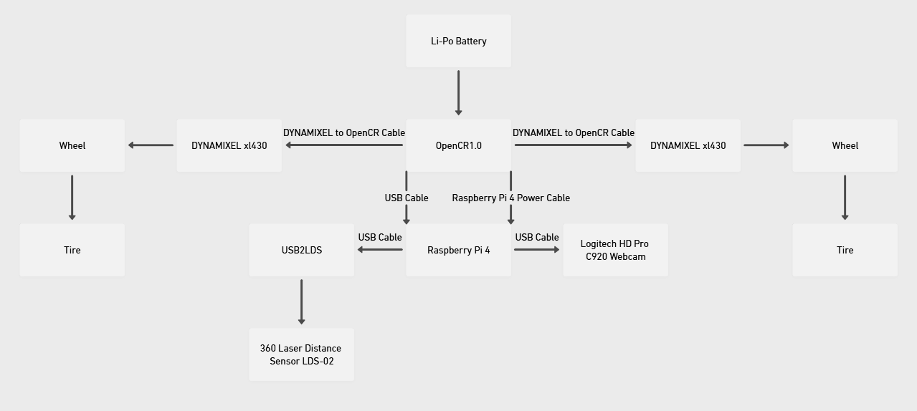
Figure 1. Block diagram of overall design architecture

Our hardware implementation involves using the TurtleBot-3 Burger along with additional sensors, specifically a 360º LiDAR and a Logitech camera. These two hardware components communicate via a router that transmits data to the PC interface of the Robot Operating System (ROS 2). The robot is also equipped with actuators that enable movement, including DYNAMIXEL/Sprocket wheels and an 11.1V battery. These wheels are controlled by the OpenCR1.0 embedded controller, which features a 32-bit ARM Cortex M-7. In Figure 1, each arrow indicates a cable or wire connection to the corresponding hardware component. To start the maze-solving process, the robot's camera will be shown a “start” AprilTag, signaling the beginning of the maze-solving logic.
Upon successful implementation of the initial phase, individuals will have the capability to observe the robot autonomously moving while simultaneously mapping its environment, as evidenced on the personal computer screen. The 360º LiDAR sensor determines the distance between itself and the nearest object through rapid emissions of infrared laser pulses. The collected data is actively mapped, and the corresponding system architecture can access this information via auxiliary hardware components. Specifically, the objective of the first phase is to enable the robot to perform a comprehensive scan of the maze’s structure and to store the data for subsequent analysis.
Successful implementation of the second phase enables the robot to accurately calculate the shortest path to the maze’s exit. Using the information from phase one, the robot will apply logic from a Python program to identify the simplest route, since the entire maze's orientation is known. An “End” AprilTag will be displayed for the robot’s camera at the maze’s exit, completing the maze-solving automation and confirming the success of the overall design.

III. Architecture

The architecture section of this document provides a detailed explanation of the design and its connections. It is divided into three parts. Section 3.A covers the architecture considerations, including the project's specifications and requirements. Section 3.B describes the hardware design and how its components are connected. Section 3.C explains the intended software architecture. Each section also provides further details on specific design choices and their reasoning.

Target architecture considerations

The design outlined in this document aligns with the specifications and requirements set forth in previous documents. Specifically, the Autonomous Maze Solving Robot Design Specification Document was developed during an earlier milestone. This document specifies that the robot should autonomously complete the maze, meaning it must navigate throughout the entire maze without human intervention. To achieve this, the robot will use both LiDAR and a camera. The project will be completed in two phases. The first phase is a basic exploration, where the robot maps the maze using LiDAR. After this, the robot will enter the calculation phase, which determines the shortest path from Start to End within the maze. During this phase, the robot should be placed at the Start position. Once calculations are complete, the robot will follow the shortest path. The specifications also include details about the sizes and dimensions of the TurtleBot3 and the maze. Additionally, they cover how the TurtleBot3 components communicate and function within the system, as well as the fiducial markers designated for Start and End points. The next section explains the design choices made to meet the hardware specifications and requirements.

Overview of the Intended Hardware Architecture and Connections between Components

As previously mentioned, the intended architecture of our design will successfully solve a maze autonomously in two separate phases. As shown in Figure 2, it is clear that the robot contains several hardware components necessary to complete the task.

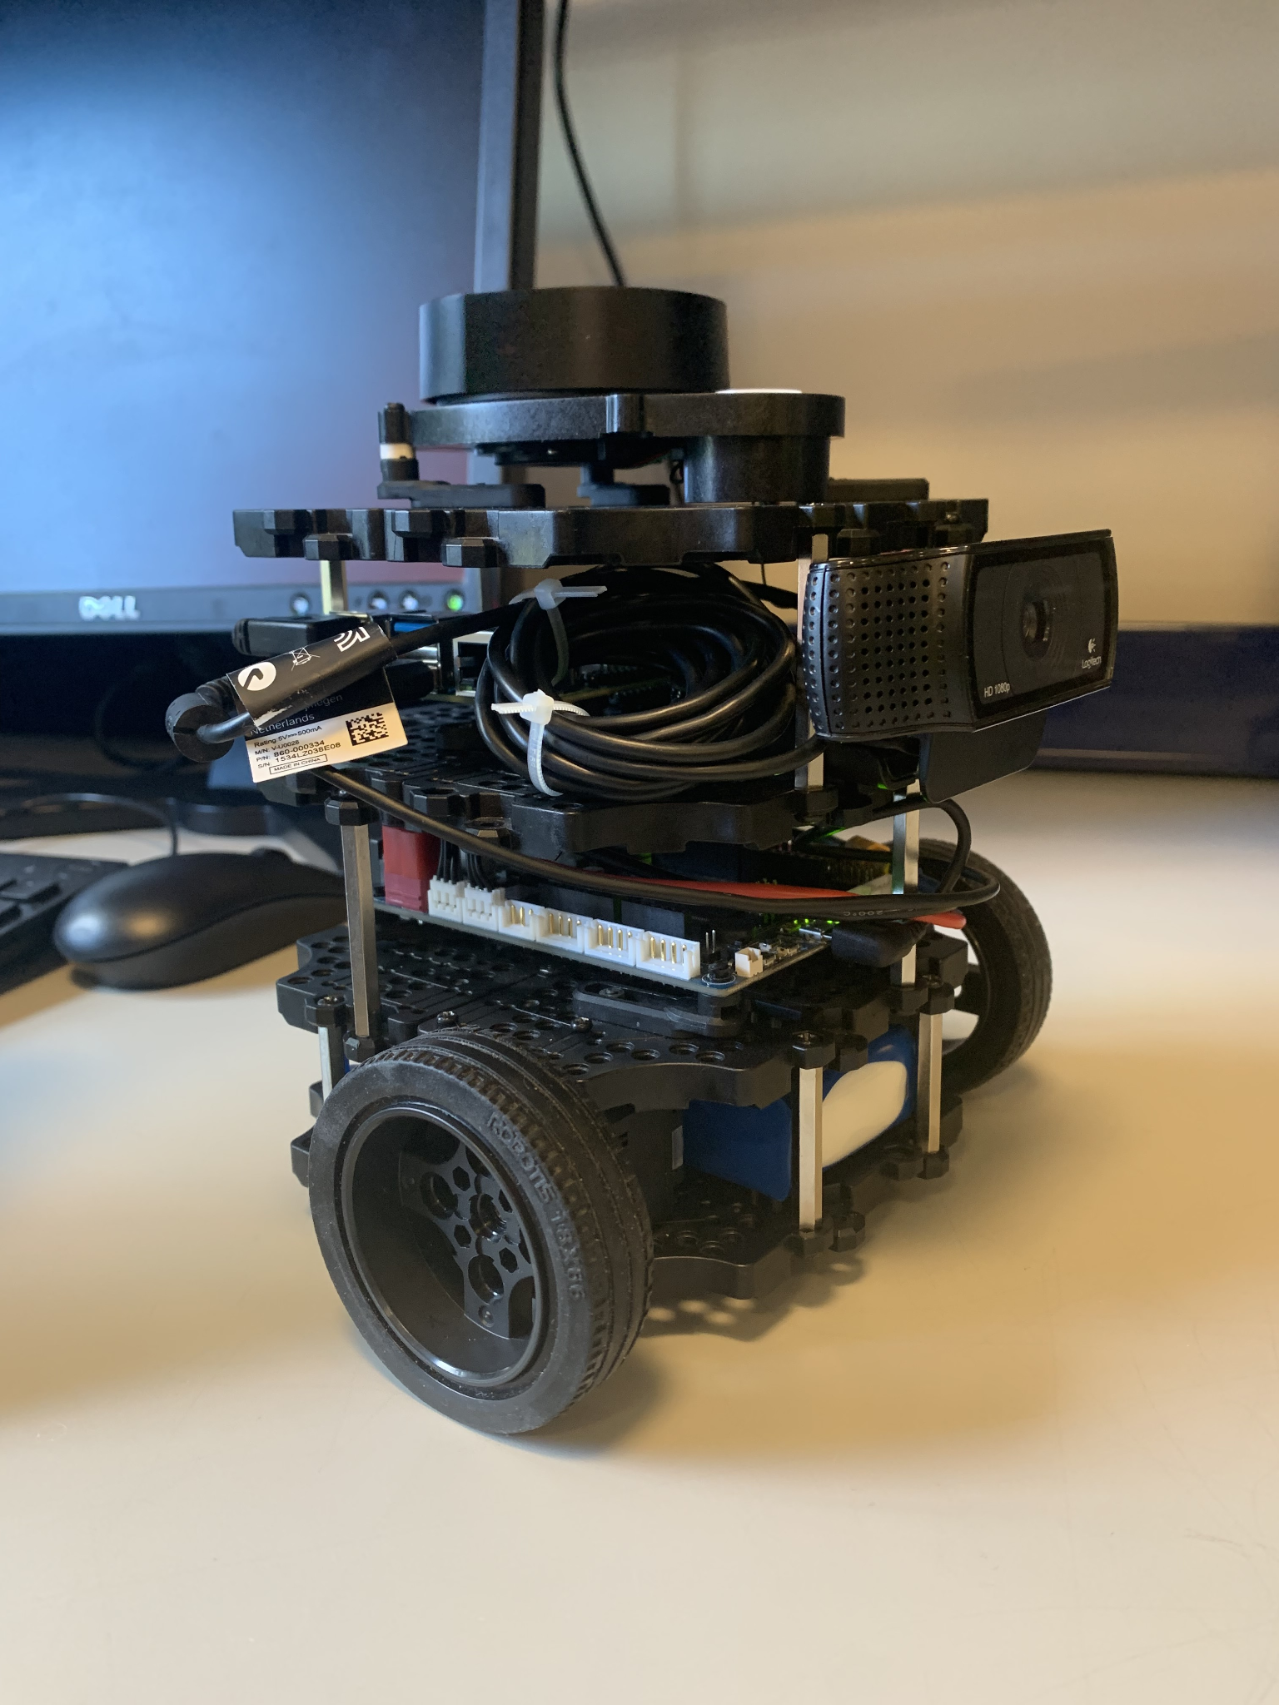
Figure 2. The full structure of TurtleBot-3 Burger

From top to bottom, the hardware components are as follows: at the very top is a 360º LiDAR sensor capable of scanning and measuring the distance to its surroundings using infrared light. In the upper middle section is a Logitech HD Pro C920 Webcam, designed to read AprilTags that mark the start and end of the maze, a Raspberry Pi 4, which functions as a key communication hub between the other hardware elements and the robot’s obstacle interpretation system, and a USB2LDS, which connects the LiDAR sensor to the Raspberry Pi and enables the PC interface to create a map of the environment. Below these are the control board OpenCR 1.0 for the robot's motor functions and the Li-Po 11.1 Volt battery at the bottom waffle plate. Figure 3 offers a close-up view of the USB2LDS. Since a camera is essential for this design, modifications are necessary to add a camera to the BurgerBot. To attach the camera, two 45 mm plate support beams should be mounted to the waffle plate holding the Raspberry Pi. These support beams should be approximately 40 mm apart, allowing the camera to sit comfortably between them. After fitting the camera, its USB cable should be bundled and secured to another plate support on the second level waffle plate with zip ties; this setup ensures the USB connection is accessible to the Raspberry Pi and keeps the camera securely in place. Figures 4 and 5 show the modifications needed to include the camera. As the figures illustrate, the plate supports provide stability, ensuring the camera remains in position as the robot moves.

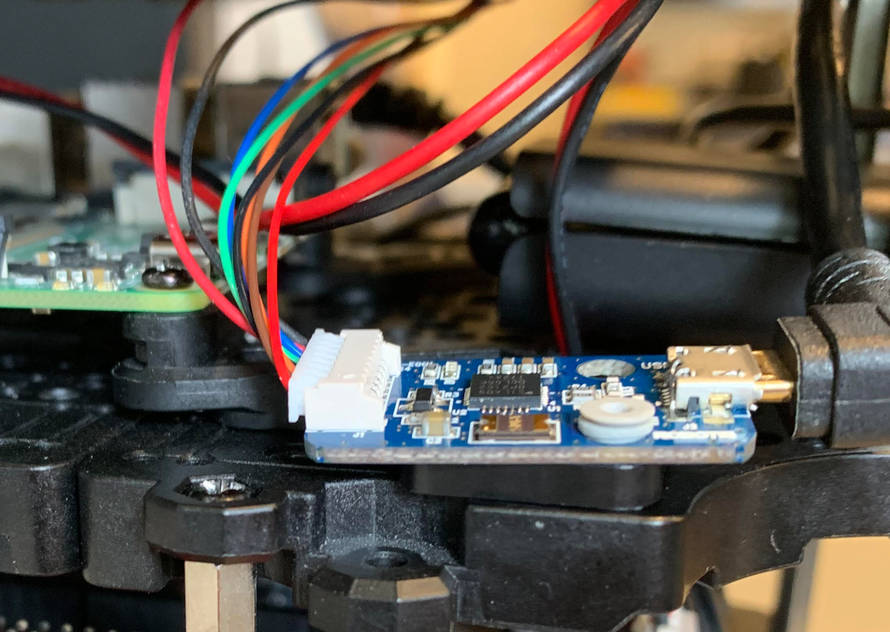
Figure 3. USB2LDS which connects to the LiDAR and Raspberry Pi 4

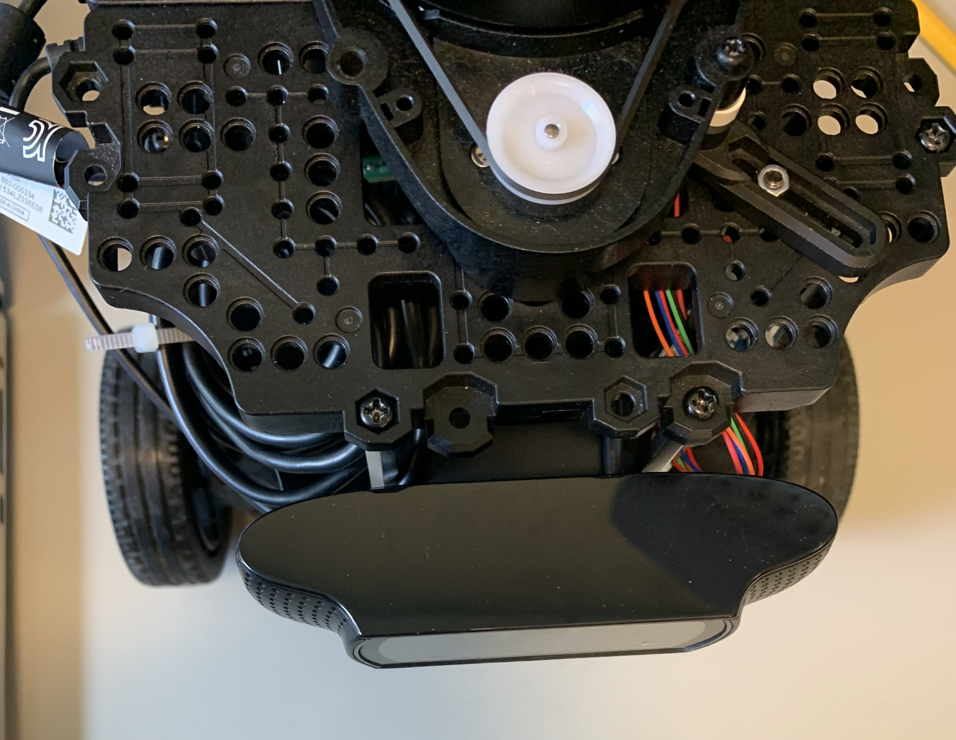
Figure 4: Top View of the modifications made to the BurgerBot to include the camera

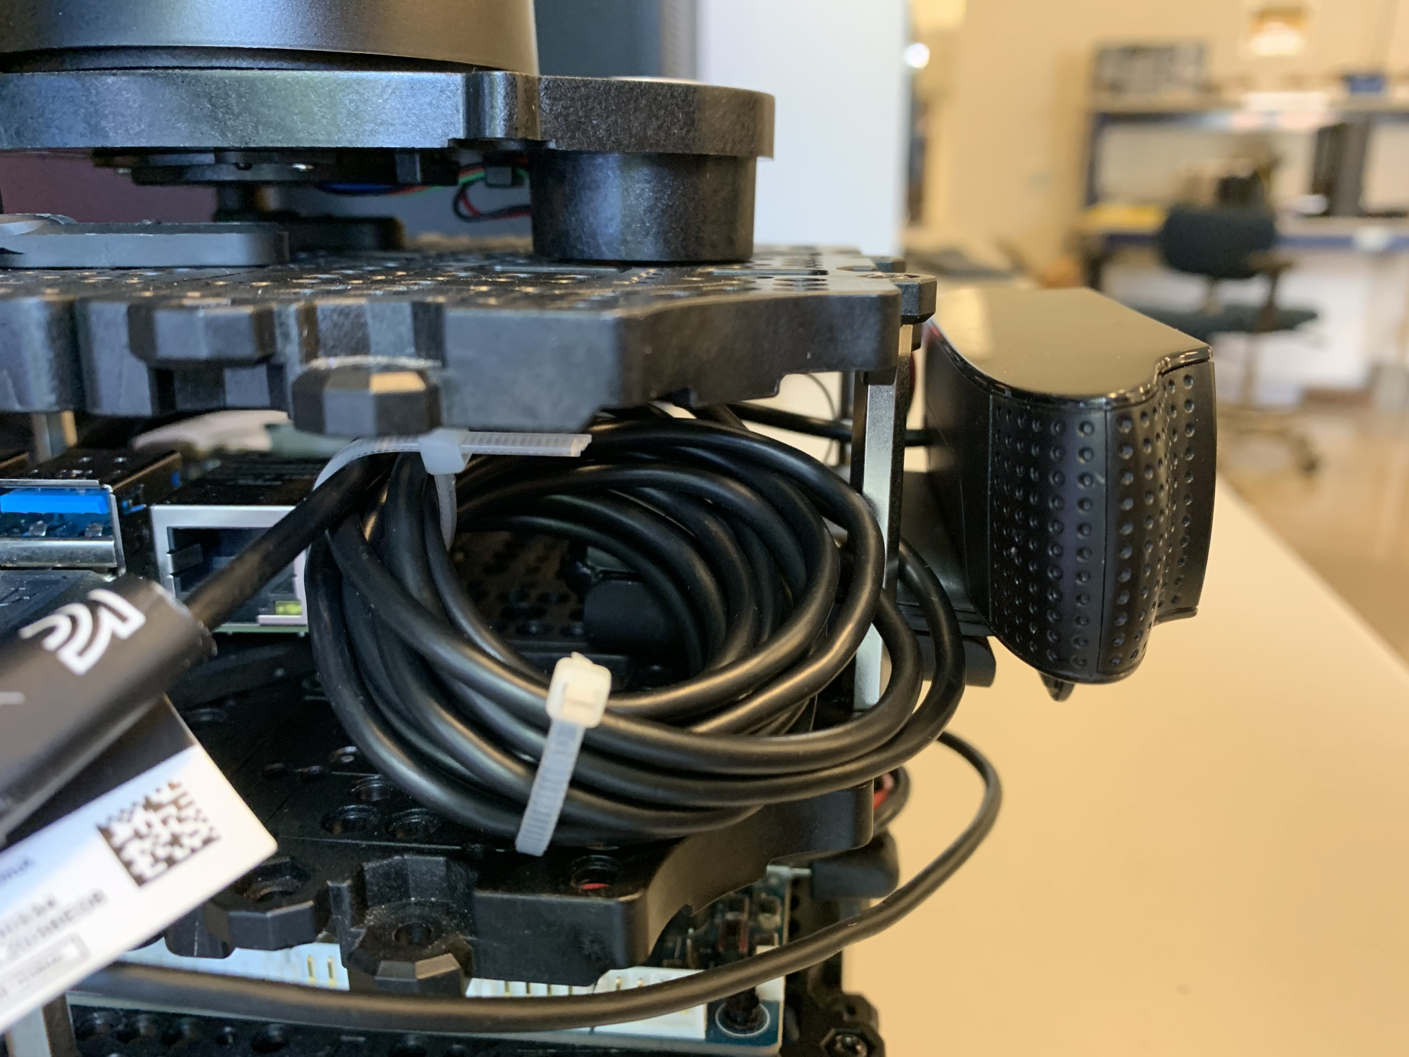
Figure 5: Side view of the modifications made to the BurgerBot to include the camera

The lower middle section of the robot houses the OpenCR1.0 embedded controller, a 32-bit ARM Cortex-M7, which connects to the Raspberry Pi 4 and the DYNAMIXEL motors/sprocket wheels at the bottom of the robot. The Li-Po 11.1V battery (not shown) and the wheels mentioned earlier are situated on the bottom-most level. To enable communication between these components, a Robot Operating System (ROS2) is used; this system establishes a client-server relationship between the hardware and the operating system through a Python script. As a result, the Raspberry Pi 4 leverages its central position in the architecture to send and receive data, which is interpreted through the internal Python script managed by ROS2. The robot can move wirelessly from a PC using an Asus 802.11ac gigabit router, which receives signals from the LiDAR and camera data from the Raspberry Pi 4. A diagram illustrating the hardware and software connections within the autonomous system is shown in Figure 6.
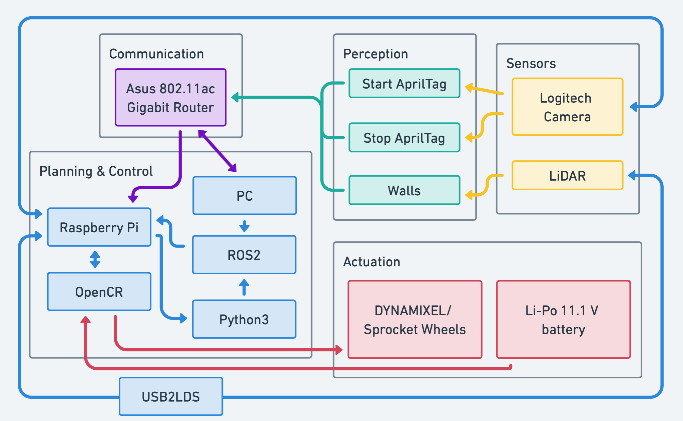
Figure 6. Connections between hardware, software, and the perception requirements of the team

The Asus router clearly acts as a crucial component for communication between the PC and the main board, Raspberry Pi 4, as shown in Figure 6. The Raspberry Pi 4 can interpret sensor and camera data, and the ROS2 interface can execute the Python script that is part of it. As previously mentioned, ROS2 establishes an internal client-server relationship between hardware and software. By creating Nodes, ROS2 can generate and pass internal goals or topics, set by Python or C++ programming, which may send signals to hardware components to perform actions. For example, refer to Figure 7, which shows an rqt_graph that enables the user to observe changing nodes and topics within the ROS2 setup, indicated by different colors. In this example, the blue node transmits information to the red topic, while the two green nodes receive information from the red topic as it is transmitted. To summarize the color coding: blue transmits data, red is the topic that receives published data, and green receives published data, as referenced in [2]. Generally, nodes can represent sensors and actuators; therefore, this concept applies to our setup with the LiDAR, webcam, and DYNAMIXEL servos. For instance, the LiDAR sensor will have a node with a Subscriber script that explicitly subscribes to the /scan topic in the ROS2 environment. This script will output the data received directly from the sensor into the terminal or ROS2 environment. The webcam is planned to function as a node with a Publisher script that publishes the type of AprilTag being read, such as Start or End. Specifically, the script would use different data types published across various topics to determine the optimal next move.

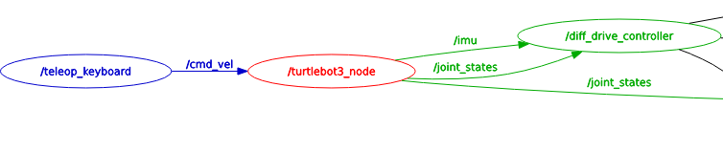

Figure 7. Rqt_graph that shows how nodes connect and communicate

The following Table 1 can be best used to summarize the purpose of each element and its connections:

Hardware Component | Purpose | Connections
360º Laser Distance Sensor LDS-01 | Perceives distance from objects by sweeping the area with a laser, collecting data capable of building a map. | - Raspberry Pi 4  - USB2LDS
Raspberry Pi 4 | A single-board computer with onboard WiFi capability serves as the central connection point for all of the hardware elements. | - LiDAR Sensor  - USB2LDS  - OpenCR1.0  - Logitech Webcam  - Asus 802.11ac
USB2LDS | A board that allows easy communication between the LiDAR sensor and the Raspberry Pi 4 board. | - Raspberry Pi 4  - LiDAR
OpenCR1.0 32-bit ARM Cortex-M7 | An open-source embedded control module with the capability of allowing the robot to move. | - Raspberry Pi 4  - DYNAMIXEL motors  - 11.1v battery
Logitech HD Pro C920 Webcam | The camera is directly supported by the Raspberry Pi 4 and can perceive AprilTags and QR codes. | - Raspberry Pi 4
DYNAMIXEL Wheel motors | Fully integrated DC motor capable of being activated by an embedded controller. | - OpenCR1.0
Li-Po 11.1v Battery | Direct power to OpenCR1.0. | - OpenCR1.0
Asus 802.11ac gigabit router | A router that utilizes onboard Wi-Fi, thus capable of sending and receiving signals to be interpreted. | - Raspberry Pi 4  - PC interface
PC/ROS2 Interface | Configured through Ubuntu 22.04, establishes a modular communication system between hardware elements and software instruction. | - Asus router  - Raspberry Pi 4
Table 1. Major hardware components and respective purpose/connection

Overview of the Intended Software Architecture

The intended software architecture of this design is still in development, so there are aspects of the architecture that still need to be designed; however, some parts of the software have already been developed for the project. These include the camera’s software, maze algorithm, and the Python node setup. The scope of the camera design will be to use pre-made Python libraries that utilize the OpenCR board to transmit data from the camera to the PC interface. The necessary libraries can be easily found through the tutorials provided for the BurgerBot and ROS2. Compared to the design for the wall-following algorithm and the maze algorithm, the camera design is relatively simple.
To enable the robot to navigate through the maze autonomously, a specific algorithm must process data from the LiDAR and use it for navigation. Wall-following algorithms simplify LiDAR’s two-dimensional navigation by treating it as one-dimensional[10]. For this design’s wall-following algorithm, the robot will use the scanned LiDAR data to navigate the maze. To meet this project's requirements, the wall-follower should perform these tasks: detect a wall, follow a wall, avoid collisions with other objects, and find the end location. Using ROS2, a node should be created that contains the wall-follower algorithm; this node will interact with other software nodes responsible for different parts of the design. The wall-follower algorithm will include various functions that allow the robot to choose actions based on its surroundings.
To determine the robot’s action, a state argument shall be used; states 0-3 will involve finding a wall, following a wall, and turning right or left. A global variable will set the direction or wall to follow. When the variable is set to -1, the wall follower resets. When set to 0 or 1, the robot will follow the left or right wall, respectively. Figure 8 illustrates, with pseudocode, how the variable functions. To enable the robot to move and execute states, three additional functions shall be created. These functions will handle the robot’s movement when following a wall and turning. The linear and angular velocities will be set for each function, controlled by two variables called linear and angular, which determine the robot’s movement. Using ROS2 libraries, the movement Twist can be imported into the Python script; this movement uses the linear and angular variables. These variables will control the speed of the robot’s wheels. The three functions will manage these movement variables accordingly. To ensure the algorithm works correctly, a check function shall verify that the robot is in the correct state based on the LiDAR data. The LiDAR data shall be imported into the Python script and used in this check function. Once the wall-follower algorithm operates correctly, the data collected during its operation will be used in the maze algorithm to find the shortest path from the Start AprilTag to the End AprilTag. When the Start AprilTag is detected, the wall-follower algorithm will run until it reaches the End AprilTag. Upon reaching this point, the robot will enter the calculation phase, which utilizes the maze algorithm.

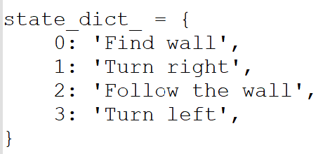
Figure 8: Pseudocode regarding the state dictations

There are many maze algorithms that could be used for this project; however, for this specific design, the algorithm in use is the A* search algorithm. The A* algorithm is a type of path-informed search algorithm. It finds the shortest path from a defined start to a specified goal. In this project, the A* algorithm will be employed during the calculation phase to determine the shortest path from the start to the finish, using the two separate start and end AprilTags as data points. The goal of the A* algorithm is to select a path that has the lowest cost. The cost can be defined by the user; in our case, it will be the shortest time, so the path that takes the least amount of time is considered the shortest by the algorithm. To do this, the A* algorithm builds a tree of paths beginning at the start node, which in our project’s case is the Start AprilTag. The algorithm explores these paths one edge at a time until it reaches the termination point[7], which for our project is the End AprilTag. To decide which path to extend, A* uses the function shown in Equation (1). The variable n in this function represents the cost of a cell. An example of a cell in a maze is shown in Figure 9. The value of f(n) is the total cost to reach a specific cell n. The functions g(n) and h(n) represent the actual cost to reach cell n from the start and the estimated cost to reach the end from cell n, respectively[6]. Most implementations of A* use a priority queue to repeatedly select the minimum-cost node to expand. During each step, the node with the lowest f(n) value is removed from the queue, and the f(n) and g(n) values of its neighbors are updated and added back to the queue. The process continues until the node removed from the queue is the end goal.

$f(n) = g(n) + h(n)$ (1)

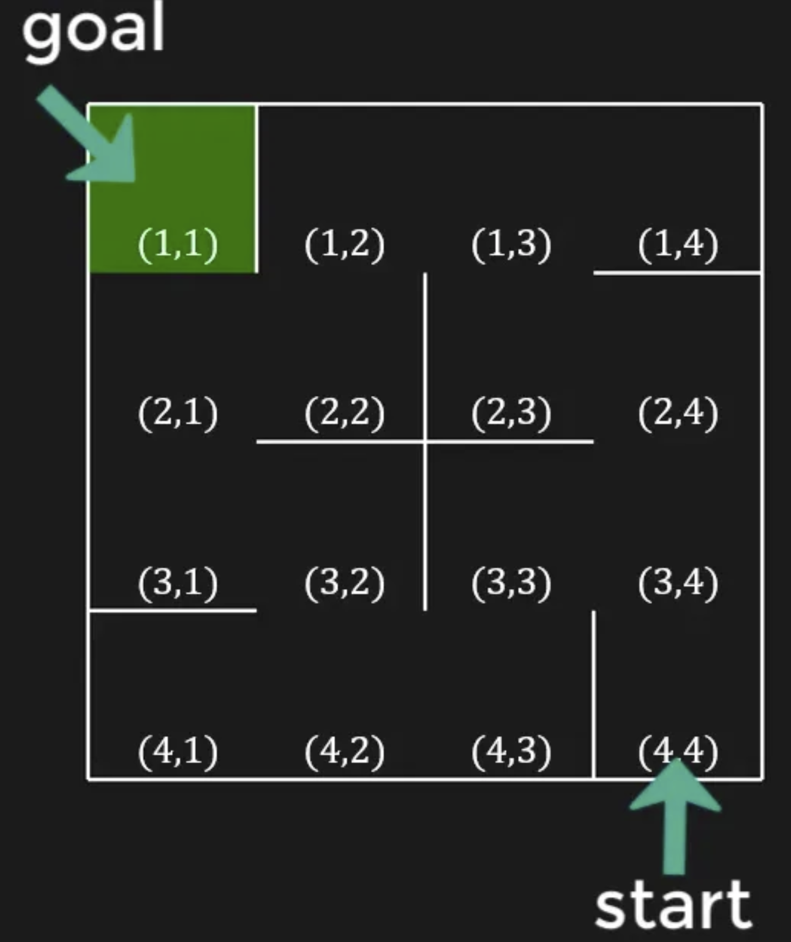
Figure 9: An example of cells in a maze[6].

The A* algorithm is the best choice for this design because it considers the cost already traveled in the maze. Compared to other maze-solving algorithms, A* is more efficient. Similar to the Breadth-First Search (BFS) algorithm, the A* algorithm is preferable because it provides the robot with a reference point to find. If the BFS algorithm were used, the robot would need more time to calculate the shortest path because it does not have the end goal in mind. In contrast, the A* algorithm offers the robot with the end goal data points. An analogy for the difference between the two is that, unlike BFS, the A* algorithm is like a compass guiding the robot toward its destination. For this project, the A* algorithm will be implemented in Python. It will take data points collected by the robot during the exploration phase and convert them into an array. The algorithm will then use this array to find the shortest path, which the robot will follow after the calculation.
As we expand the scope of our architecture, the software component of the project must include this algorithm. To understand where the algorithmic logic resides in the system, we need to discuss the fundamental parts of our hardware operating system. As previously mentioned in the sections, the Robot Operating System (ROS 2) uses a unique hierarchy. Without applying the specified project constraints, we can interpret the basic ROS 2 architecture and identify essential elements. The first key element of the environment is a node. A node can be created through various methods, such as being instantiated within a class inside a C or Python script, or through the Linux command line. This serves as a reference point that may contain a subscriber or publisher and will perform a specific task [4]. The second key element of ROS is the topic. A topic connects nodes and provides a communication bus for message exchange [5]. A publisher is part of a node that transmits data to the topic, while a subscriber is part of another node that consumes data from the topic; the ratio of publishers to subscribers in a ROS project does not have to be 1:1. The diagram in Figure 10 best illustrates how these fundamental elements communicate. Based on this project’s specifications, our team has determined that we will develop nodes representing the two boards: Raspberry Pi 4 and OpenCR1.0. From these nodes, we plan to create subscriber-publisher pairs for the LiDAR sensor connected to the Raspberry Pi 4 and the OpenCR1.0. Specifically, the LiDAR data will be published as a specific data type to the topic, aligned with LiDAR data interpretation standards. A subscriber from the node associated with the OpenCR1.0 will then use this published data to determine the robot’s next move, as this board is connected to the wheels. The logic employed by the subscriber upon receiving LiDAR data will be the previously mentioned A* maze-solving algorithm.

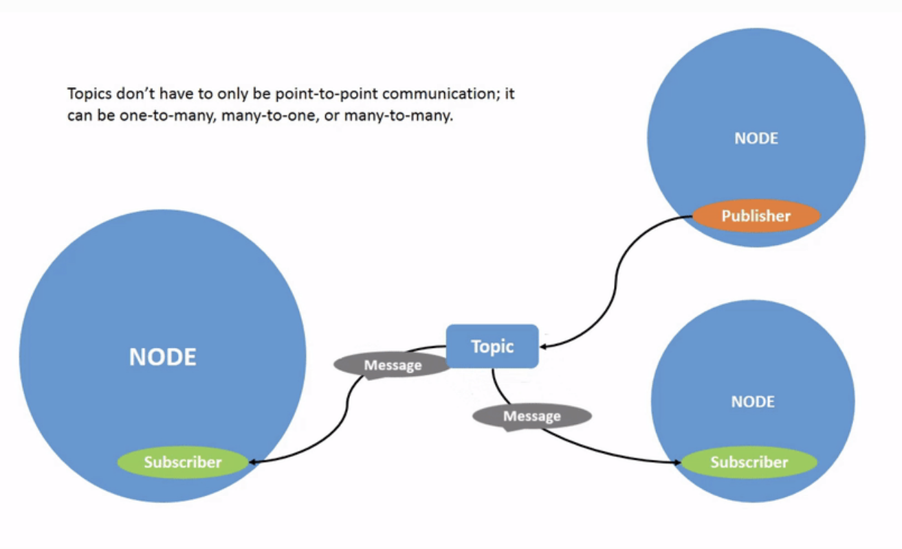

Figure 10. Publisher-Subscriber communication from Node to Topic to Node [5]

IV. Interfaces

This project includes multiple components that need to interact reliably with each other. Each component has a specific purpose, such as the Raspberry Pi 4, which acts as a central hub and communicates with most of the other components. The Raspberry Pi will connect to the LiDAR, OpenCR1.0, and the Logitech HD Pro C920 Webcam. Several programs must be properly installed on designated components, and precise packages are necessary to enable communication between elements. To achieve this, an operating system must be installed; for our team’s design, we will use Ubuntu. The first step is installing the latest version of Ubuntu, which can be downloaded from their official website. Robotis provides a step-by-step tutorial on installing the correct programs to ensure the robot functions properly. Installing ROS2 packages on the PC is the initial recommended step. In this project, only the ‘Humble’ version of ROS2 will be used, as it is the only version employed throughout the project. The robot must be assigned a unique identification number or ID. Having a unique ID is essential because if more than one robot share the same ID, they will follow the same instructions. For this robot’s design, the ID of 30 will be assigned. The next key component will handle most of the heavy lifting.
The Raspberry Pi 4 is the next component to be configured. The tutorial covers this thoroughly, enabling the reader to understand what needs to be done in order. One crucial step is to install the Ubuntu Server version on the Raspberry Pi; it is important to choose the server version so the PC can communicate with the Pi and vice versa. The next step for the Raspberry Pi is to connect it to the router that will be used for communication between the PC and Raspberry Pi 4. There is a network configuration file that must be edited on the Raspberry Pi to connect it to the router; this process does not need to be done on the PC since it is hardwired into the router with Ethernet. The SSID (Service Set Identifier) and the password for the router are required to connect to it. To find the SSID, the command “Netsh WLAN show interfaces” is entered into the PC’s command prompt since it is connected to the router. The password was provided by Professor Sonar, the project’s owner. The ROS 2 Humble version will be installed on the Raspberry Pi, which will also allow the components to communicate as ‘nodes’. One of the next steps is to install the necessary packages, as specified by the tutorial. Some packages will enable the Pi to communicate with the LiDAR, camera, and finally, the OpenCR 1.0. A program will run to check the connection between all of the robot's components, as shown in Figure 11. The command “ros2 launch turtlebot3_bringup robot.launch.py”[1] is essential because it provides a quick and easy way to verify that everything is properly connected to the Pi.

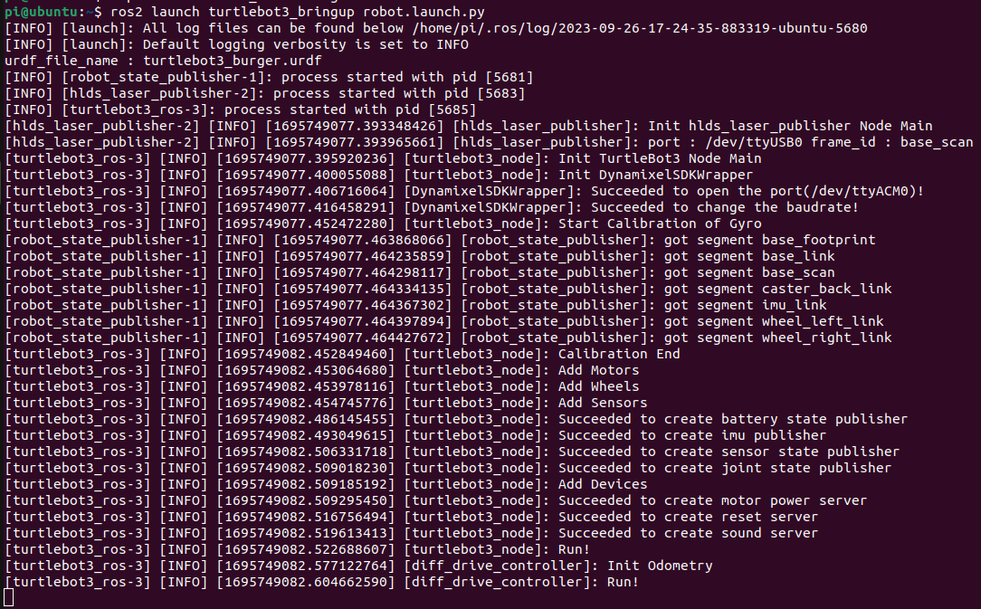
Figure 11. ROS2 node connections

The configuration of the LiDAR should be completed next. This can be done using a few commands from the tutorial. Since the LDS-02 was broken before starting this project, LDS-01 is used throughout. The LiDAR connects to a device called USB2LDS, which makes it easy to use the LiDAR; this device acts as the connector between the Raspberry Pi 4 and the LiDAR. There is a program called “RVIZ2,” a ROS2 tool that lets the user visualize robot features. This program should be used to view the LiDAR output and will eventually help visualize the maze through LiDAR mapping. An example of the LiDAR in use, mapping nearby objects in RVIZ2, is shown in Figure 12.

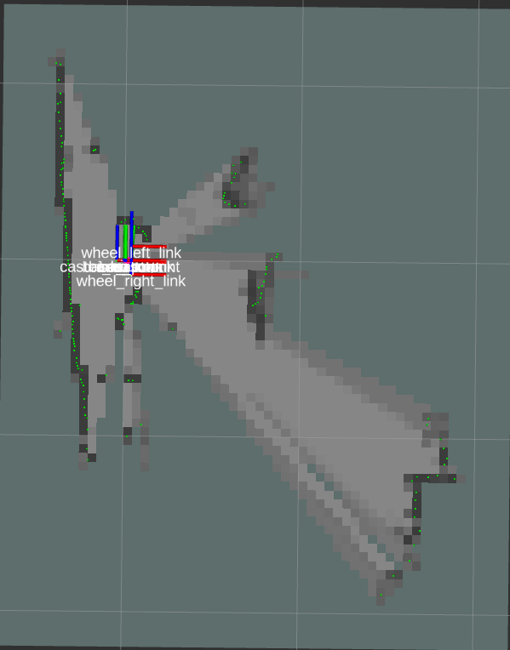
Figure 12. RVIZ2 LiDAR data

The camera for this design should be a Logitech HD Pro C920 Webcam. A USB cable must connect the camera directly to the Raspberry Pi 4. The only requirement for the camera to function is to have a graphical interface for the Raspberry Pi, such as the Ubuntu desktop version, and the packages for OpenCV, which enable camera use. After installing the packages, the next step is to identify the video capture device used by the camera; this can be done with the command “ls -ltr /dev/video*, " which lists available captures. To determine the correct capture, a trial-and-error approach is typically used, but usually, the capture will be video0 or video1. The final step to receive feedback from the camera is to use the OpenCV library within Python. When the script runs, a window will display the live video feed from the camera. An example of the camera's functionality is shown in Figure 13. The next step is to connect OpenCV and ROS2, which will convert the OpenCV image format to the ROS2 image format. This process can be carried out using the tutorial provided by The Construct [8]. It involves executing several commands in the console. Once set up, the next task is to recognize AprilTags. AprilTags are similar to QR codes but are designed to encode smaller data payloads; for example, AprilTags encode between 4 and 12 bits, while QR codes can carry up to 3248 bits. In this project, AprilTags will be used as detection markers for the robot to recognize the start and end of the maze. Multiple versions of AprilTags exist, and most likely, the “Tag36h11” version will be used because it includes a border around the tag, which can help reduce errors in detection. The bridging must be established beforehand so that data from the USB camera can transfer through ROS2, enabling the AprilTag detection program to analyze the video stream and identify if an AprilTag is present in the output.

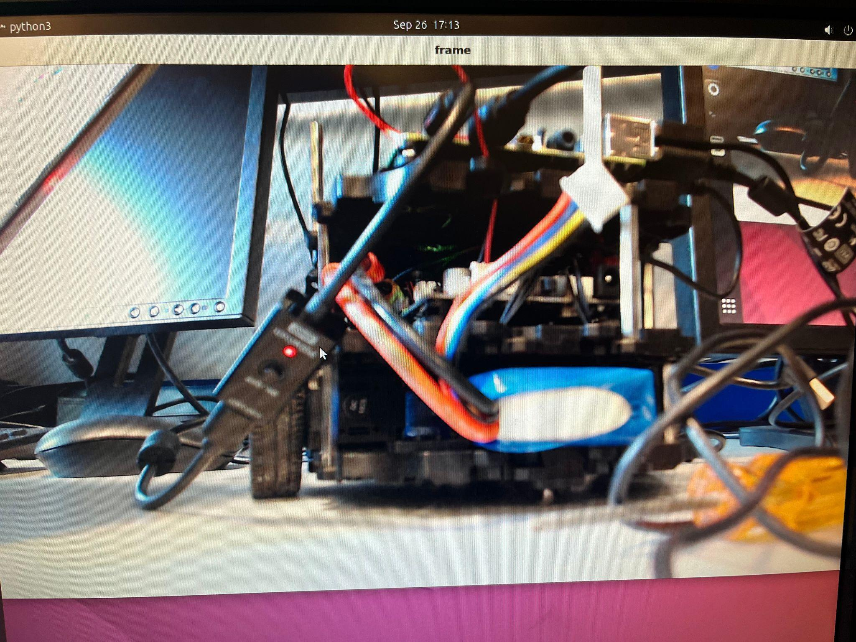
Figure 13. Logitech HD Pro C920 Webcam

After receiving video feedback from the camera, the next step was for the camera to recognize Apriltags using the USB camera. This enabled the robot to determine the start and end positions of the maze. To achieve this, a Python program will be used to detect these tags by accessing the USB camera and identifying specific tags, which can be configured within the program. An example of the Apriltag detection in action is shown in Figure 14. In this figure, the program displays a neon green box around the detected Apriltag. The program also recognizes the specific tag family and keeps track of the number of tags in the frame, as indicated by the 0 shown in the figure. This step was crucial because the next phase involves creating a unique ROS2 package to send information from the publisher node to the subscriber node for future implementations.

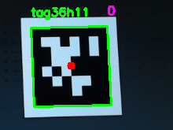
Figure 14. Apriltag Detection

The OpenCR1.0 controls the robot's mobility and is solely used to manage the motors that enable the robot to move forward and backward. To set up the OpenCR1.0, a few commands are required to update its firmware and establish communication between the OpenCR1.0 and the Raspberry Pi 4. While following the tutorial, the Humble version should also be used for this board. If there are different versions among the components, problems may arise; therefore, it is essential to use the same version across all parts of the system.

VI. References
[1] Name, Your. “Robotis e.” Manual, emanual.robotis.com/docs/en/platform/turtlebot3/bringup/. Accessed 29 Sept. 2023.
[2] “Using Turtlesim, ROS2, and RQT.” Using Turtlesim, Ros2, and Rqt - ROS 2 Documentation: Humble Documentation, docs.ros.org/en/humble/Tutorials/Beginner-CLI-Tools/Introducing-Turtlesim/Introducing-Turtlesim.html. Accessed 29 Sept. 2023.
[3] “Robotis e.” Manual, emanual.robotis.com/docs/en/platform/turtlebot3/quick-start/. Accessed 5 Oct. 2023.
[4] “Understanding ROS 2 nodes with a simple Publisher - Subscriber pair.” ROS 2 Workshop, ros2-industrial-workshop.readthedocs.io/en/latest/_source/basics/ROS2-Simple-Publisher-Subscriber.html#understanding-ros-2-nodes-with-a-simple-publisher-subscriber-pair. Accessed 12 Oct. 2023
[5] “ROS 2 Documentation: Foxy.” Understanding topics, docs.ros.org/en/foxy/Tutorials/Beginner-CLI-Tools/Understanding-ROS2-Topics/Understanding-ROS2-Topics.html. Accessed 12 Oct. 2023
[6]M. A. Naeem, “A-Star (A*) Search for Solving a Maze using Python (with visualization),” Medium, Oct. 26, 2021. https://levelup.gitconnected.com/a-star-a-search-for-solving-a-maze-using-python-with-visualization-b0cae1c3ba92
[7]Wikipedia Contributors, “A* search algorithm,” Wikipedia, Mar. 10, 2019. https://en.wikipedia.org/wiki/A
[8] “How to Integrate Opencv with a ROS2 C++ Node.” The Construct, 30 Aug. 2023, www.theconstructsim.com/how-to-integrate-opencv-with-a-ros2-c-node/.
[9]“AprilTag.” Apriltag, april.eecs.umich.edu/software/apriltag. Accessed 12 Oct. 2023.
[10]K. Bayer, A. De, and D. Koditschek, “Wall Following for Autonomous Navigation.” Available: https://sunfest.seas.upenn.edu/wp-content/uploads/2018/07/12-bayer.pdf
‌

